Task 1 — 08 Marks

Sign in to the AWS Management Console:

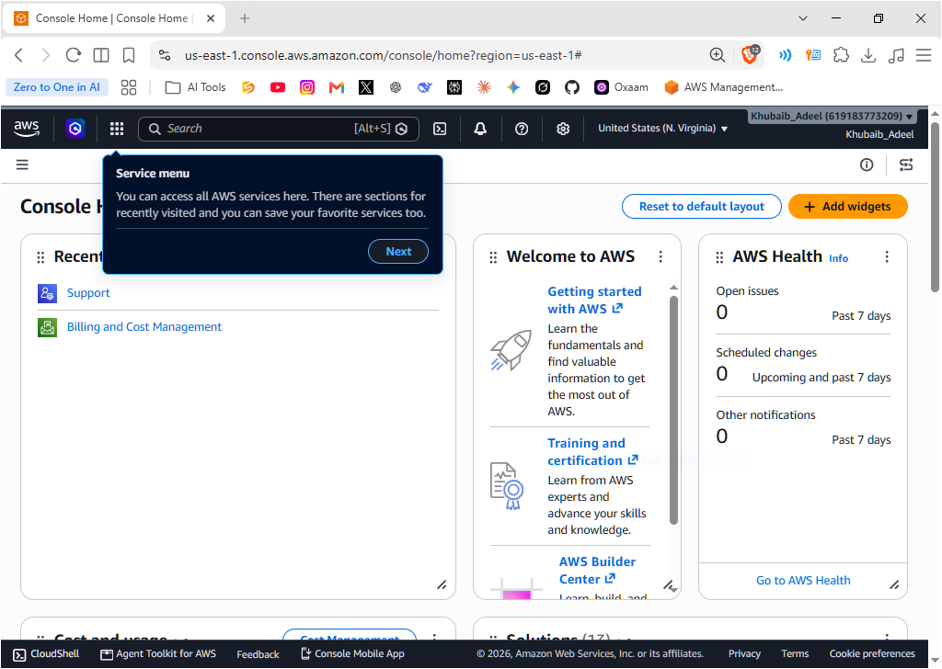

Navigate to the IAM Service:
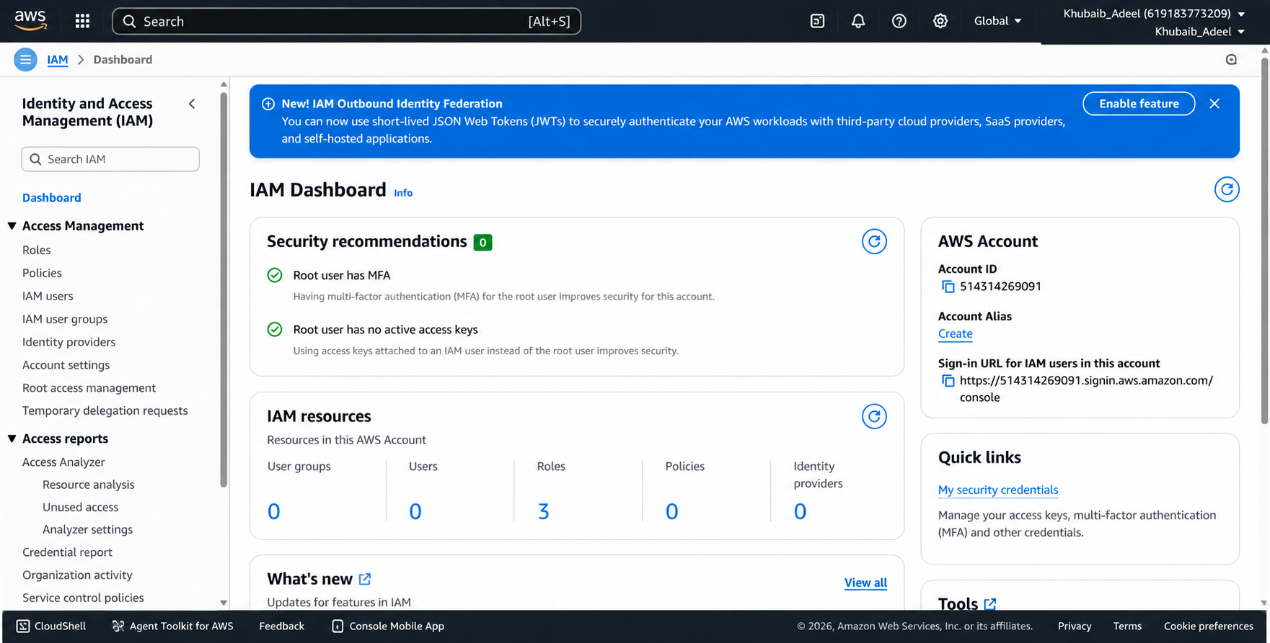

- Create a new IAM User (name it e.g., trainee-admin):
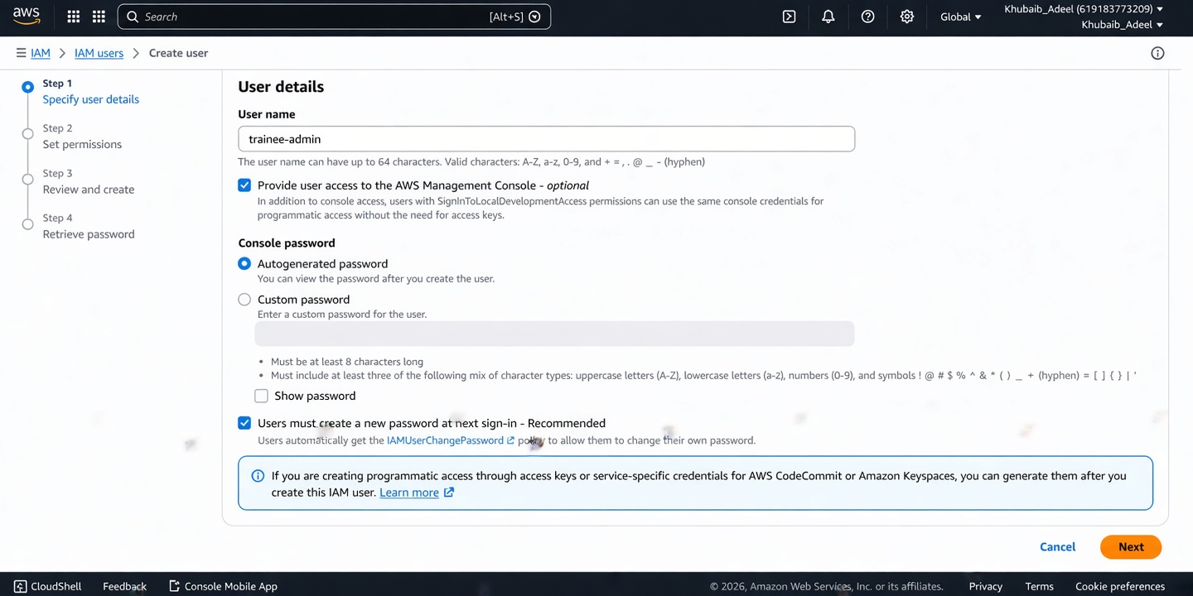

- Enable AWS Management Console Access for the User and set a Custom password:
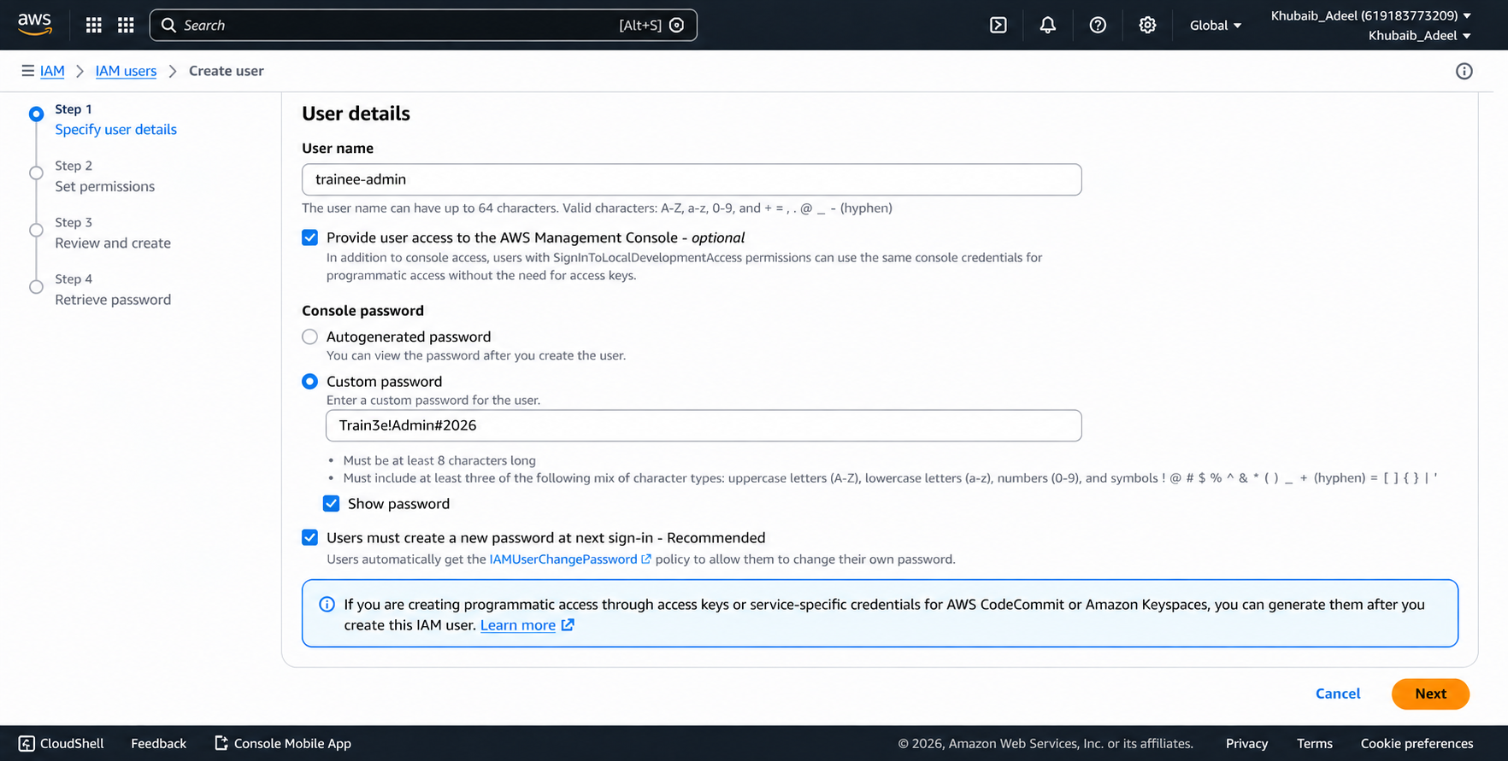

- Review and Create the user:
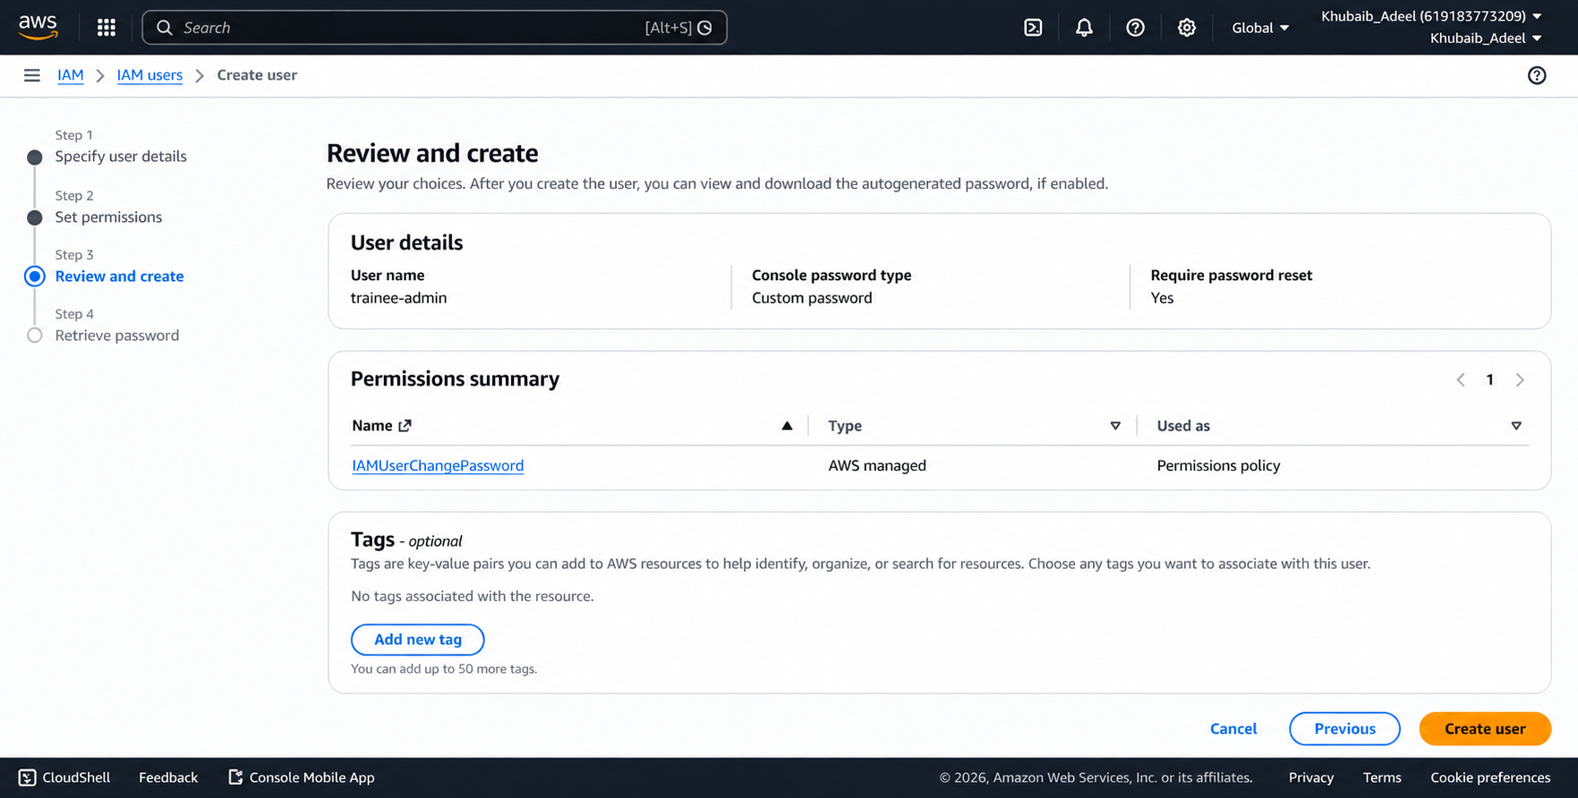

- Sign out from the root account:

- Create a new Key Pair, download the .pem file, and keep it safe:

- Under Network settings, allow SSH traffic from My IP:

- Keep storage at the default Free Tier eligible size:

- Review all settings and click Launch Instance:

- Wait until the instance state becomes Running and take a screenshot of the running instance:

